Inspiration & Reference of Medias:

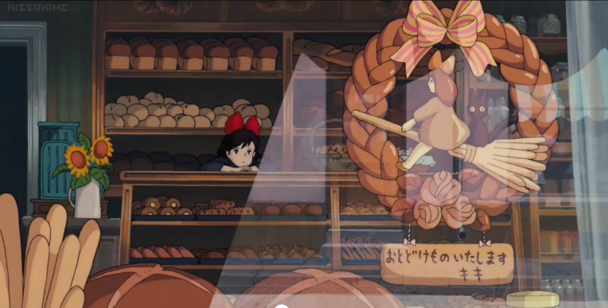
Kiki’s delivery service:
This anime film by studio Ghibli, really inspired me. The bakery is set in the urban areas of the small city, near the sea. Kiki temporarily lives in the bakery, working on her delivery business as well as helping out at the bakery to earn her stay. From this I really like the idea of animating a traditional bakery in a western style. There is a taster of what it is life behind in the kitchen as well as selling products at the till, as well as the boring slow day with no customers.

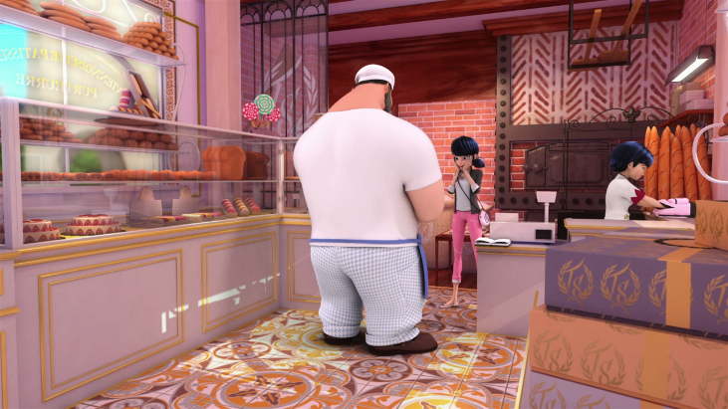
Miraculous ladybug:
The bakery (patisserie) is located in Paris (this bakery exists in real life). The main character lives on top of a bakery, her parents own a small popular bakery downstairs that serves French desserts. This is where I got the idea of a French bakery. This is set in a city which was my main idea, but I’m starting to think of having it in a small town or in a rural area of a city like the bakery in Kiki’s delivery service film. Not many customers visit as they rely on orders and preparing for big events.

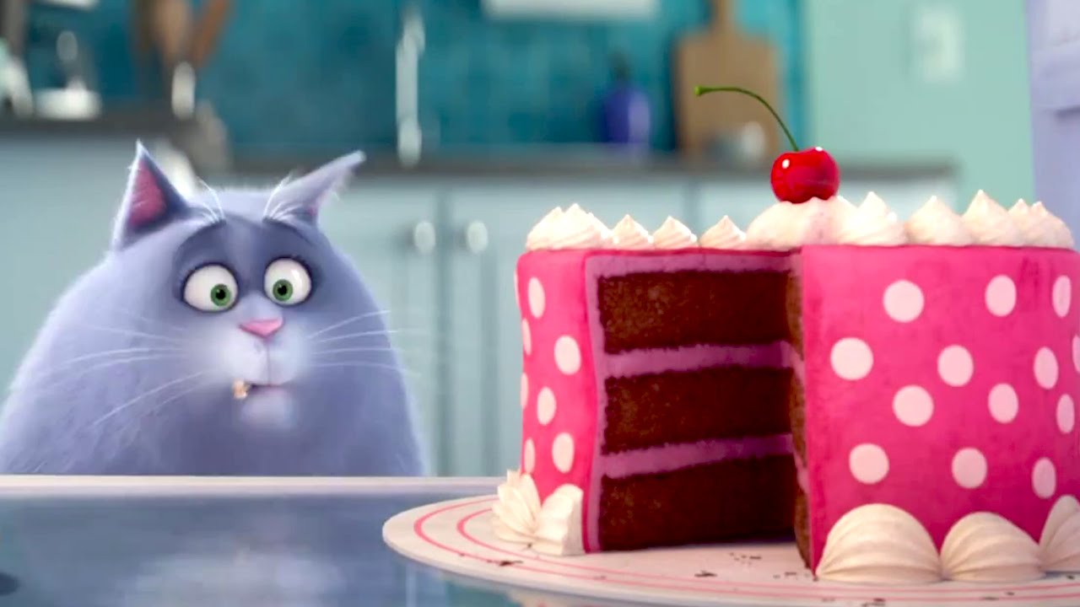
The secret life of pets:
Since I had the idea of a Fat cat who’s lazy in the bakery, making an assumption that the cat is well fed and likes to eat the food provided by the baker. Which is quite similar to the cat in ‘The secret life of pets’.
The last three shows I got my research from, all have a bright colour pallet specially designed for the kid’s interest and to make everything cheerful and interesting. The cat who’s Chloe, is a foodie who prefers human food more than the average cat food, which explains her fat and lazy composure. She has the typical traits of a cat, except the eating basic cat food. Similar to the cat I’m trying to achieve. He is spoiled with tasty sweets and breads and sometimes messes around in the bakery because of his chubby state making it impossible for him to be a stealthy cat.
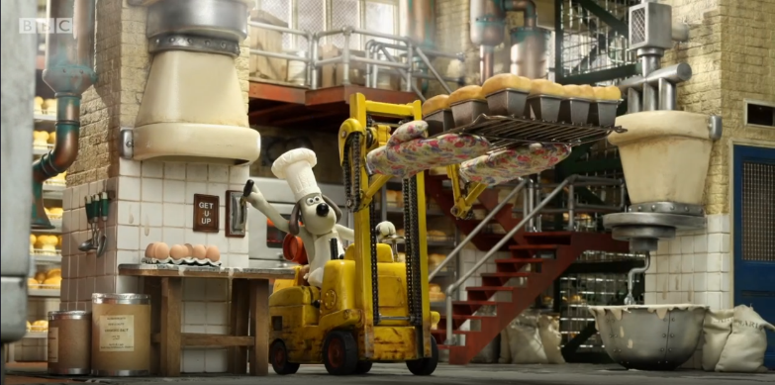
Wallace and Gromit: A matter of Loaf and Death:
I watched this episode recently, this was suggested by my peer as it explores bread making in a factory. It was entertaining overall. This is the perfect video I can use for bread rising as an animation. I could also use documentaries, but this seems like the fun option, especially in a bread factory with a baker and he’s pet creature dog, similar to my animation idea. Wallace and Gromit have dull yet an interesting colour palette. I may not use the technical skill which is stop motion, as well as the fact that it is set in a bread factory (I’m doing a small bakery). However this still gives me small ideas of few industrial things that will be used in the kitchen, to make it seem realistic to run a business.

A labour of loaf:
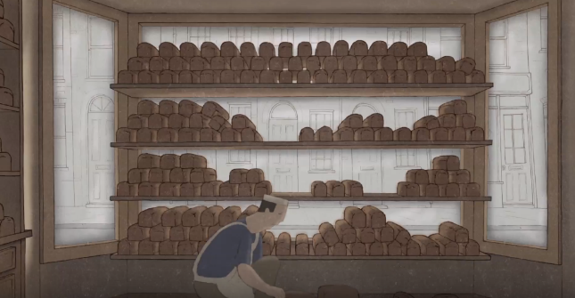
It is an animation produced by graduate students at Arts University Bournemouth as a final undergraduate year project. This is specifically set in a bread bakery, showing the process of kneading dough and the process, as well as adding a deep message. The colour scheme is dull, boring really fits the animation’s motives, however the opposite of what I’m trying to achieve. At the end there is a variety of different bread shapes and styles to inspire me when decorating the bakery.

Ratatouille:
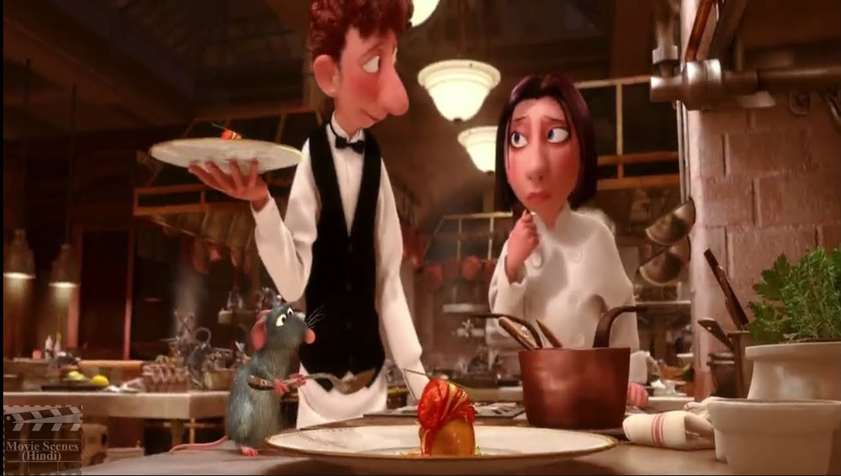
This is a 3D medium, completely different medium to what I’m producing. However I would be able to use the colour scheme, concept art as reference. The noses are really exaggerated, similar to the round pink nose of the rat, signifying the phrase ‘any one can cook’, making everyone similar to each other. The colour scheme is somewhat posh and dark, rather than the bright, which suits the restaurant vibe in France/ Paris. The OST (Music), is a lot similar to this animation, as I want a French style song in the background by an accordion. Both are food based obviously, however this is more main food based something to explore when concepting other restaurant in my town.

Art style analysis

I will be analysing art styles from different Medias, such as YouTube videos (short films), TV series, films, as well as pictures. This will help me reference and add to my art style. A lot of these are French animations, which is similar to the setting I’m trying to achieve for the FMP.
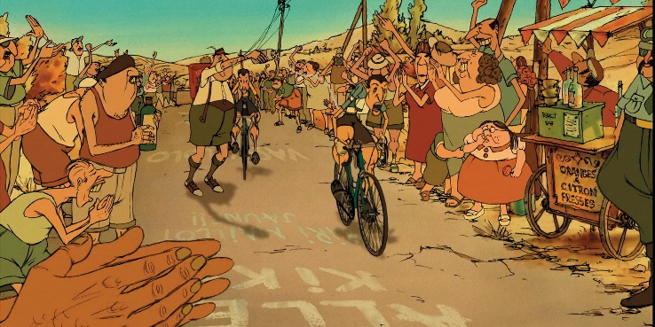
The Triplets of Belleville:
Although I didn't finish the whole film, I watched more than half of it to understand its aesthetics and art style to relate it to my project. It is a French animation, which is similar to what I want to achieve, however it's style is a bit too detailed, I'd love to implement a beautiful style like that, but with the amount of time I've been given it could be close to impossible. I also want to experiment with my own sketchy style in few areas. The colour scheme didn't seem to inspire me either.

Princess and the frog:
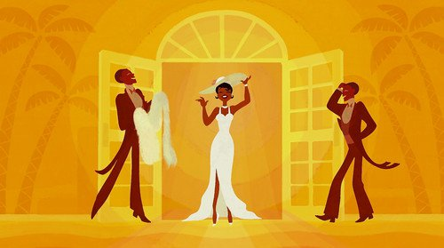
Or a separate part of film, ‘Almost there’ This is where Tiana daydreams about her future dream of owning a restaurant, and the animation transitions from the signature Disney 2D animation style to a flat art style. Which in my opinion I really liked, and since I want somewhat of a simple straightforward style in few parts like while animating the baker mix or use the dough. It keeps it simple and interesting. The colour palette includes many yellow tones, which is kind of similar to what I’m aiming for, but I want to be able to add browns to the yellows.
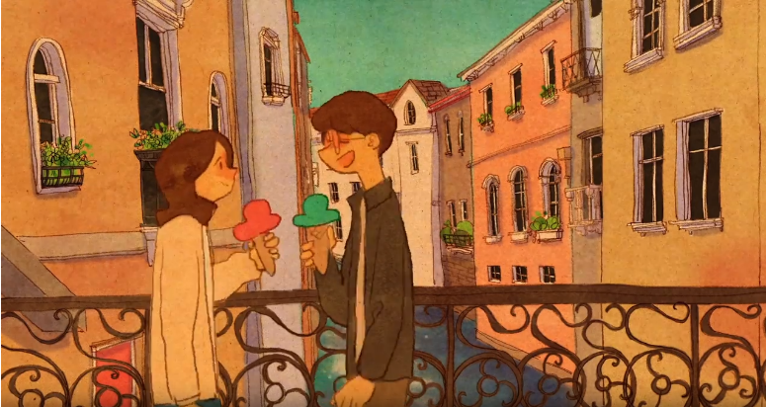
Love is – By PUUNG:
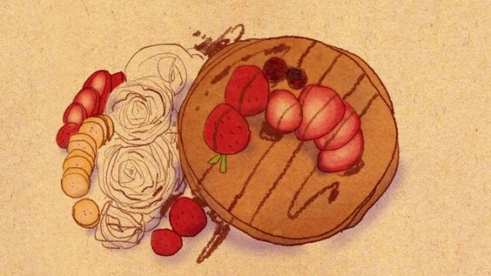
On YouTube, an animator makes short animation videos about a life with a couple, set in Paris, the animation style is quite French in itself. So I really admire this style, especially the building and the simplistic bouncy animation. The use of a texture on the animation is also a really fascinating idea that I want to as well insert into my animation. The colour scheme is warm with a lot of browns, similar to what I want to produce but with yellows included as well. This was one of the main animations that really inspired me to do something similar of what a French animation style would be, however her methods include the traditional method. Drawing on paper every frame. I will be creating mine digitally.

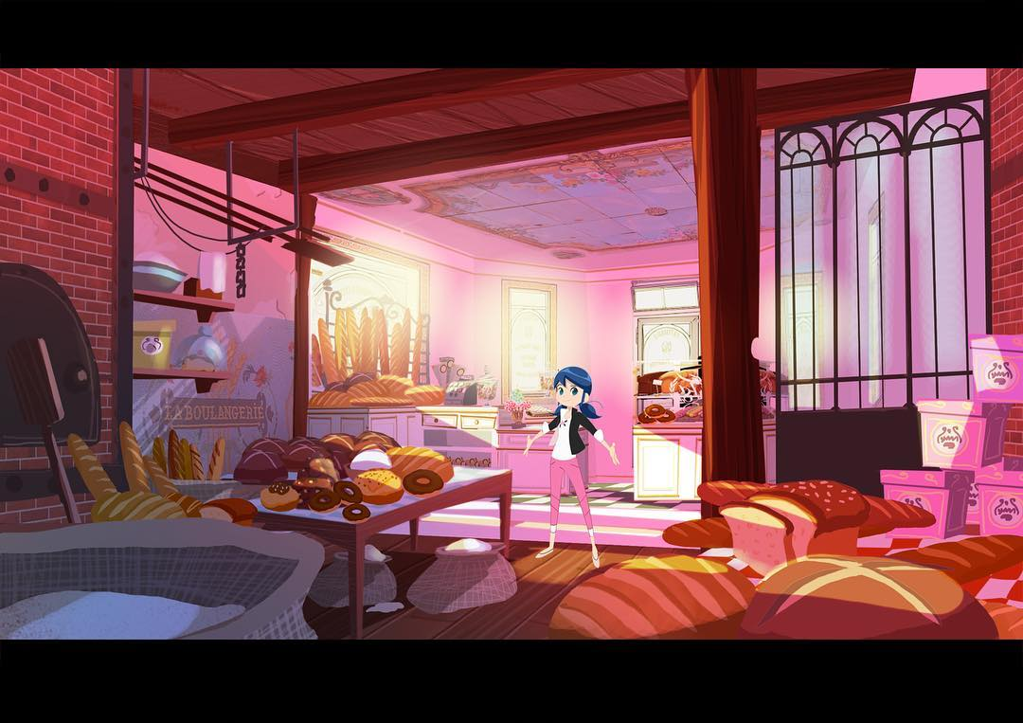Miraculous ladybug Web series:
I’ve already mentioned miraculous ladybug on the previous page about the protagonist living in a bakery in Paris. However they also have a web series with more simplistic 2D animation posted onto YouTube.
Here is a screenshot of her bakery in a basic 2D style, as I want to be able to contrast between detailed styles and simple flat style for easier animation to make this possible.

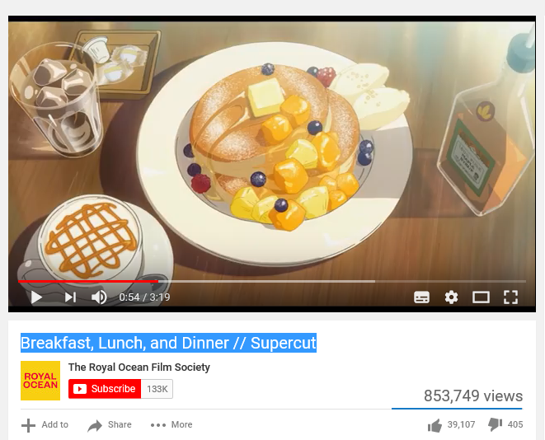
This video really inspired me to create food in animation for my FMP project. It’s a montage of food in different animations including stop-motion, 2D, Anime, etc. At first I thought of something simple and stale like modelling dishes, but soon had the idea of making it into a 2D animation set in a restaurant or food shop. It’s a topic everyone gets excited about, especially the younger generation.
I will be using this video to also reference the different style the food are designed, animated in. They are mostly from Anime. There are also credits below, so I can also check what the animation title is.
illustrative

https://www.youtube.com/watch?v=sReQrbJVc6c
https://www.youtube.com/watch?v=RK-I6LxXJsA

